

# 3rd annual

# st. charles Place block party

# st. charles Place block party

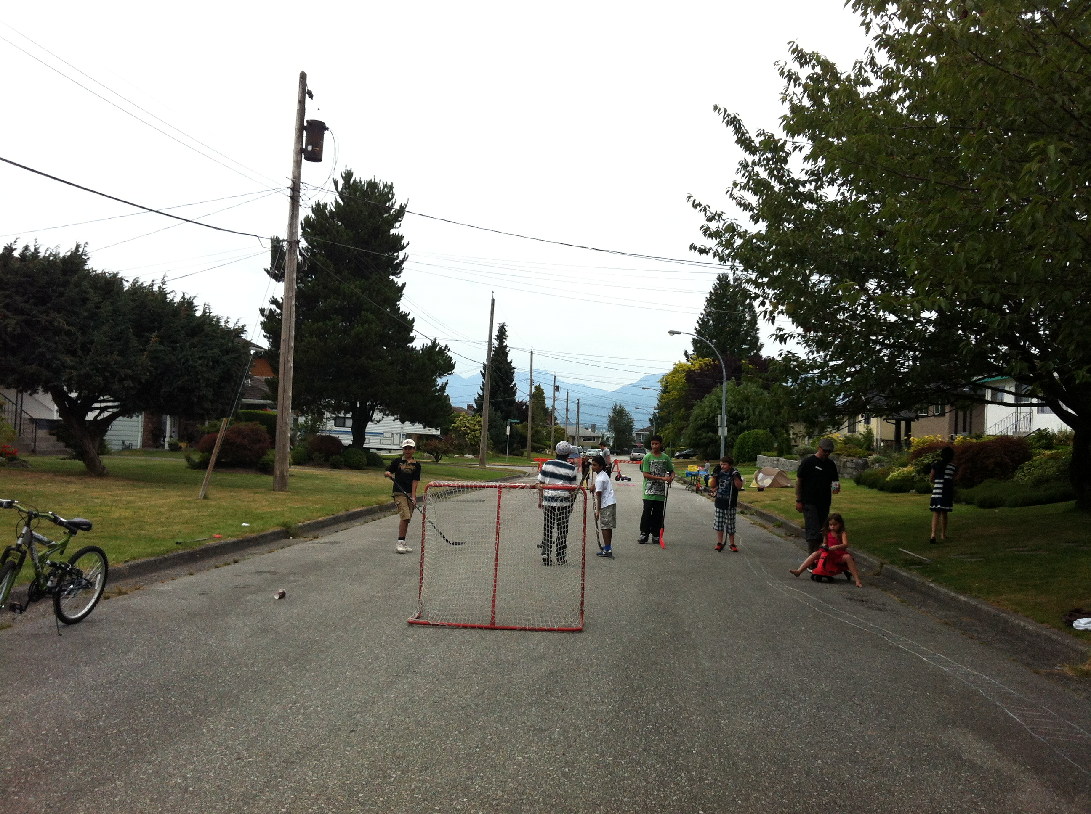

Block Party

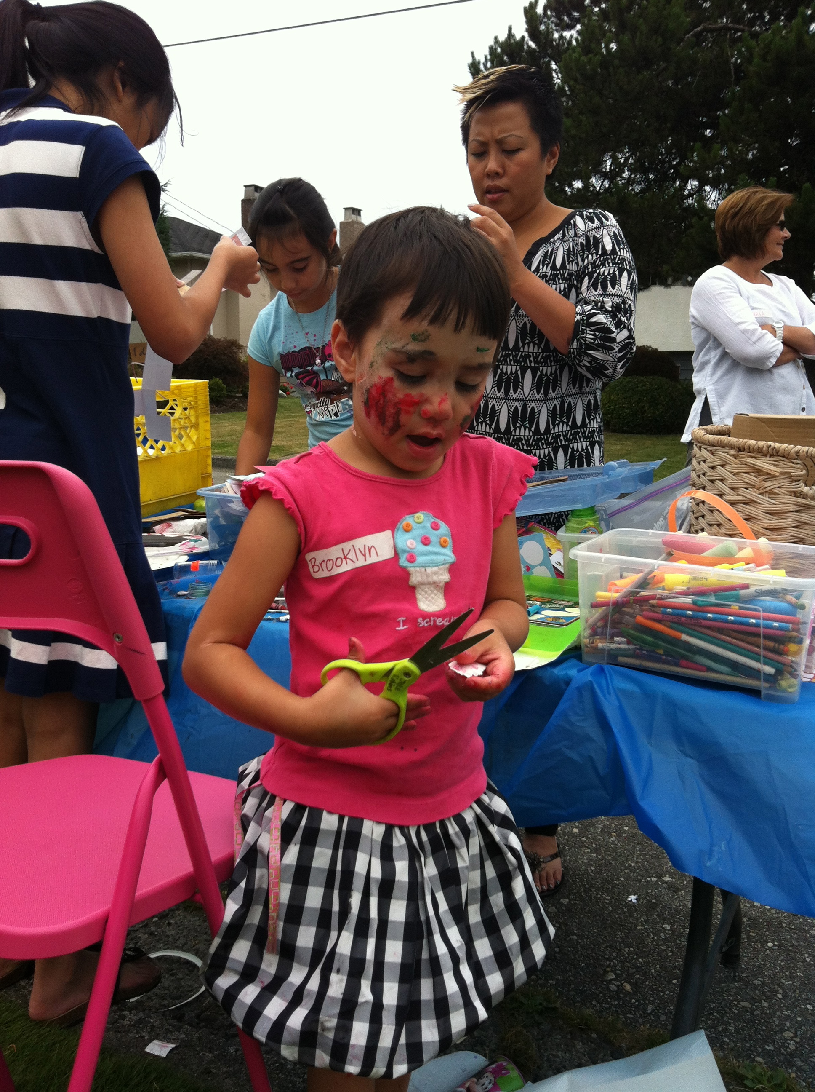

**Come out for games, food, bike rides, street hockey, bocce, music and much, much more**

Date: **Sunday August 10, 2014**

Where: **St. Charles Place from the cul-de-sac to Bryant St.**

Time: **3pm to dusk**

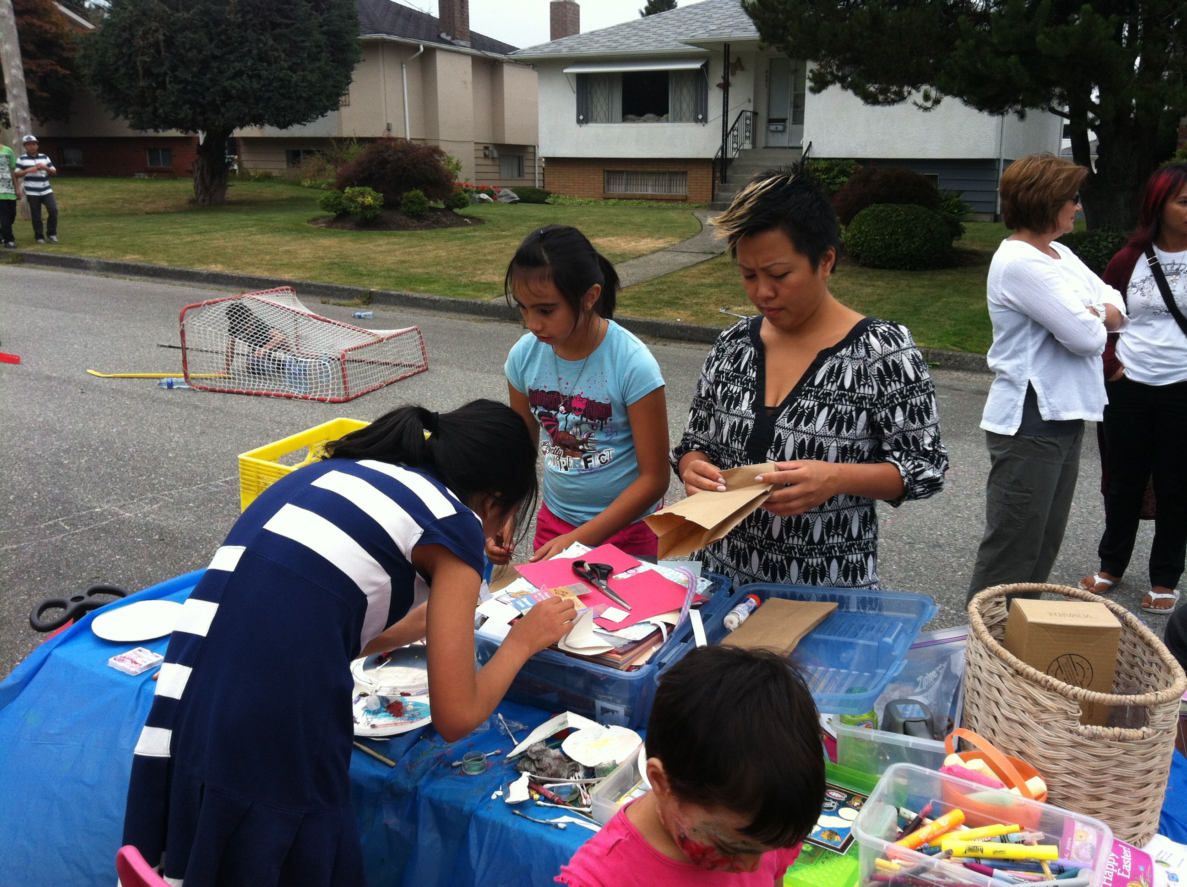

**Please note that St. Charles Place will be blocked to traffic on this day. Alley access will be unrestricted**

**RSVP: Heather at** [**heatherrobins99@gmail.com**](mailto:heatherrobins99@gmail.com) **or Diane at 604-435-7325**

**Multicultural Potluck**

**Please bring a dish to share with your neighbours.**

**Bring your own chair, plate and cutlery**

**Please RSVP by August 2nd**